1. What is CSS Grid, explain with example.

CSS Grid Layout provides a two dimensional layout system, controlling layout in rows and columns.

Eg—

<!DOCTYPE html>

<html>

<head>

<title>CSS Grid</title>

<style type="text/css">

.wrapper {

display: grid;

grid-template-columns: 1fr 5fr 2fr;

grid-template-rows: 5fr 20fr 5fr;

grid-gap: 10px;

height: 720px;

}

header {

grid-column-start: 1;

grid-column-end: 4;

}

footer {

grid-column-start: 1;

grid-column-end: 4;

}

.wrapper * {

background: orange;

display: flex;

justify-content: center;

align-items: center;

margin-bottom: 1px;

margin-right: 1px;

}

</style>

</head>

<body>

<div class="wrapper">

<header class="items">HEADER</header>

<nav class="items">NAV</nav>

<div class="items contents">CONTENTS</div>

<aside class="items">SIDEBAR</aside>

<footer class="items">FOOTER</footer>

</div>

</body>

</html>

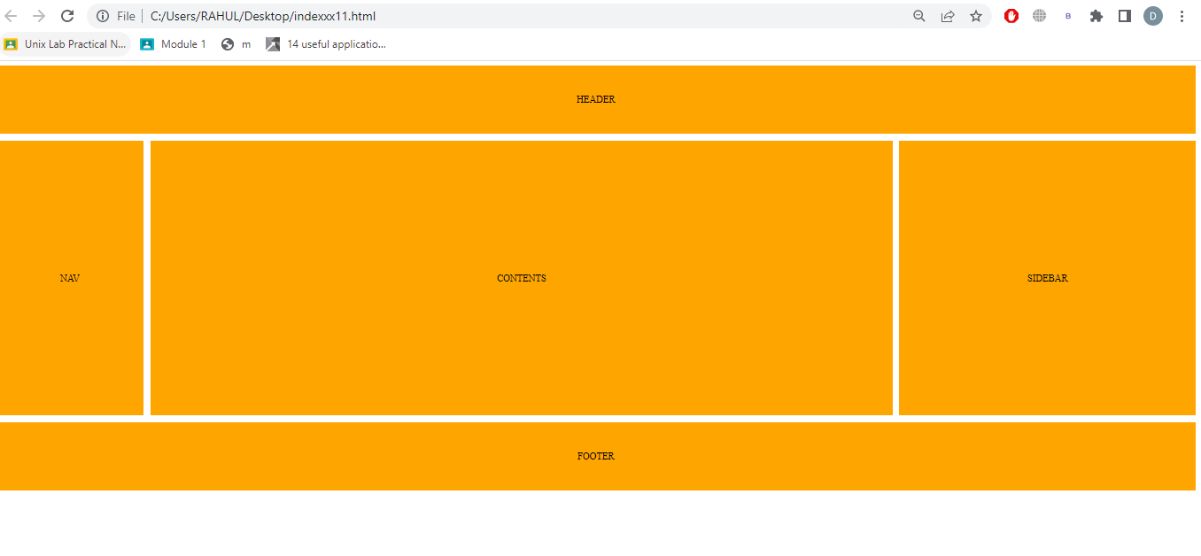

1. What is web accessibility? If you want to make your page accessible which font unit will you use?

Web acccebility means people with use web equally they have lots of befits also we can take eg ----suppose someone people cannot hear they can use captions to read also heading label with use web equally

The WCAG font size for large text has greater contrast than something half the size. a larger font size lets in more of the background that sits behind the text.

1. List common web safe fonts between Windows and Mac System. Explain font stack.

### Lists---Arial narrow, Times New Roman, Times, Courier New, Georgia , Arial Black, Comic MS, Franklin Gothic ,Serif

### list of fonts and font keywords used to let a browser know our preferred and  fonts. Or creating relevnent list of fonds based on operating system fonts have diffent ratios means small large letters like that ax OR aX

### body{

### Font-family: veranda, Arial

### }

1. List which format of web font is supported by which browser.

TrueType Font (TTF) and OpenType Font (OTF)

TTF and OTF font files  They are supported in all modern browsers, except for Internet Explorer, for which they are only partially supported.

Web Open Font Format (WOFF)

WOFF is the most supported of all font file types,. In fact, it is supported by almost all browsers except older versions of Android Browser and older versions of iOS.

Embedded OpenType (EOT)

EOT is a font file type only supported by Internet Explorer, and works on versions Internet Explorer 8 and above. Because of it’s limitation to only Internet Explorer.

1. What is browser reflow and repaints.

repaint occurs when changes are made which affect the visibility of an element, but not its layout. Examples of this include outline, visibility, background color. Of the element

reflow madhe changes hotatat affect the te layout of a portion of the page madhe use hota